NTP web-only Save Failover process
Overview
The save failover process has been designed to prevent data loss in the event that the ‘engine’ (the instance of our e-Assessment, running in a web browser on the user’s PC) is unable to return result files to CEM’s back-end systems.
The most likely reasons for this are:
- A local (school/LA) firewall blocking the result save message to CEM
- Heavy demand on CEM’s systems causing requests to our web-services and database to time out.
When the candidate finishes the test, the engine attempts to save the final result file back to CEM. It will attempt to do so three times, with a time-out of 60 seconds on each attempt. If it is still unable to save back to CEM, the save failover routine will be activated.
Save failover dialog
If the engine is unable to save results back to CEM, the user will see the following dialog:
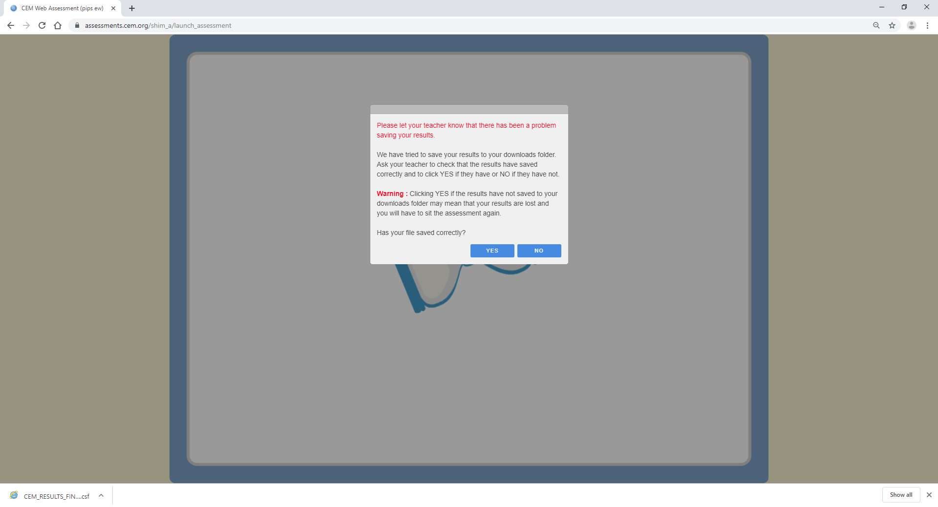
(All screenshots are from Google Chrome.)
The invigilator needs to check the .CSF file has correctly saved to the ‘downloads’ folder.
If the save failover has saved correctly, the user will see a “CEM_RESULTS_FINAL_XXX.CSF” (where XXX is a long string of numbers and letters) file appear in the bottom left hand corner of the browser window. This may look slightly different, in different browsers. The invigilator can also open the browser’s ‘downloads’ folder and check if a result file with that name has appeared with a creation date/time within the last minute or so.
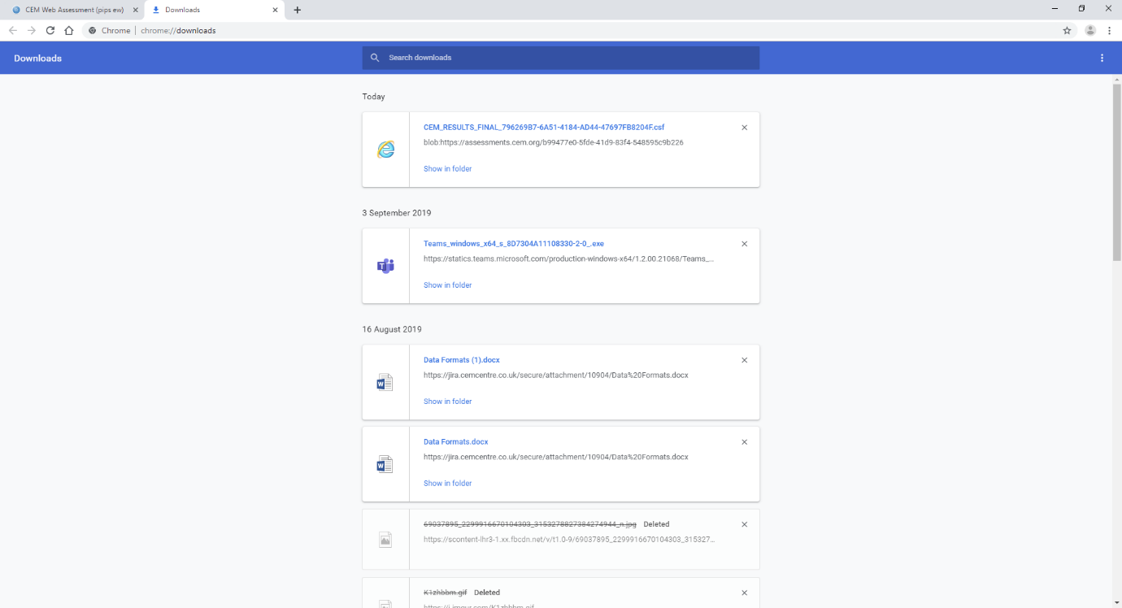
We recommend invigilators copy this file immediately to a USB drive or a common server location, to facilitate easy upload to CEM.
If they are satisfied the results have saved correctly, they can click ‘YES’. They will then see the following dialog and the test will finish as normal:
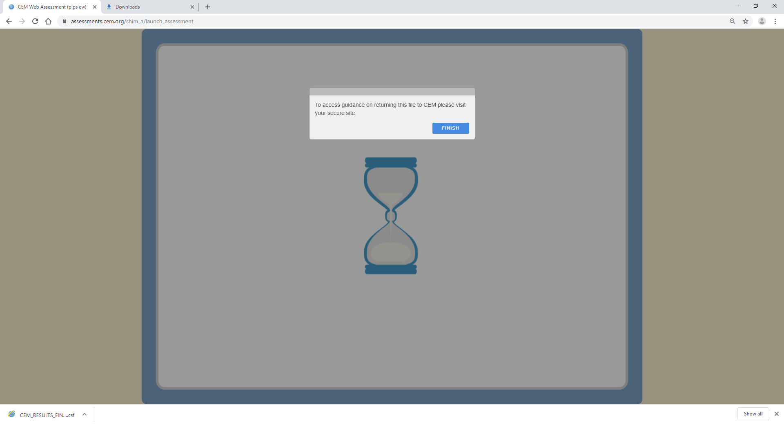
If the file has NOT saved correctly, the invigilator should click ‘NO’ and the engine will attempt to save the results again.
The engine attempts to save the file to the ‘downloads’ folder five times and the user will see the same dialog each time, assuming they do not click ‘Yes’.
If it they are still unable to verify a file has saved to the ‘downloads’ folder, they will be taken to the copy & paste dialog.
The copy & paste dialog
As a last resort, when the user has clicked ‘no’ five times, the engine will display a dialog containing the raw result XML and a ‘copy’ button. Users should click the ‘copy’ button and then paste the contents into a Notepad (or similar) file and return it to CEM by e-mail.
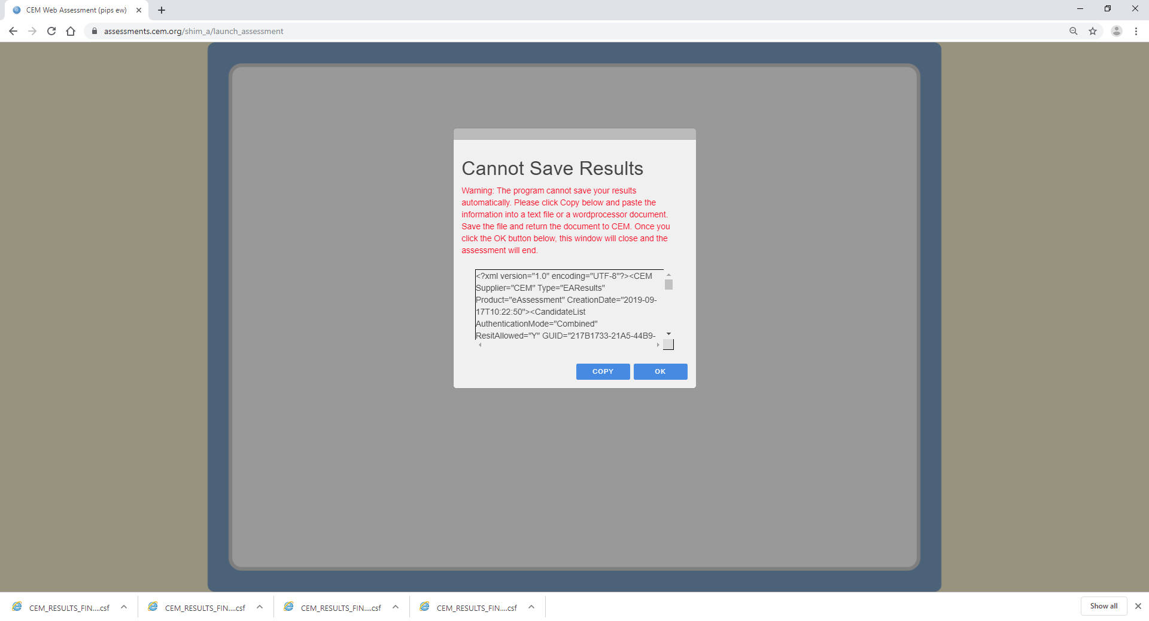

Locating .CSF files
It is essential invigilators are aware of the save failover routine and instruct candidates to put their hand up if they see any of the above screens.
However, some candidates may forget to tell the teacher and simply click ‘Yes’ when they see the Save Failover Dialog and close down the assessment.
The first we might hear about this is an angry teacher ringing up to point out their feedback is missing or the progress report shows them as ‘pending’ or ‘in progress’.
The teacher will need to ask the candidate to log into the machine where they took the test, open the internet browser ‘downloads’ folder and look for the .CSF file. If this has happened for several pupils, they will need to do it several times. This is why it is best to copy the files to a USB stick or central file server when it happens.

Uploading .CSF files
Invigilators will need to return the .CSF files to CEM using the usual result upload pages on Assessment Centre and plus sites.

E-mailing files to CEM
Sometimes, as a last resort, it may be necessary to return data by e-mail. Schools need to be aware that .CSF files and any files created by the copy-paste dialog are unencrypted. When doing so, they should zip the file(s) into a .zip archive, password protected by their Secondary+/InCAS+/etc password.

